SCREENSHOTS OF TODO_APP

1. Initial Screenshot of App

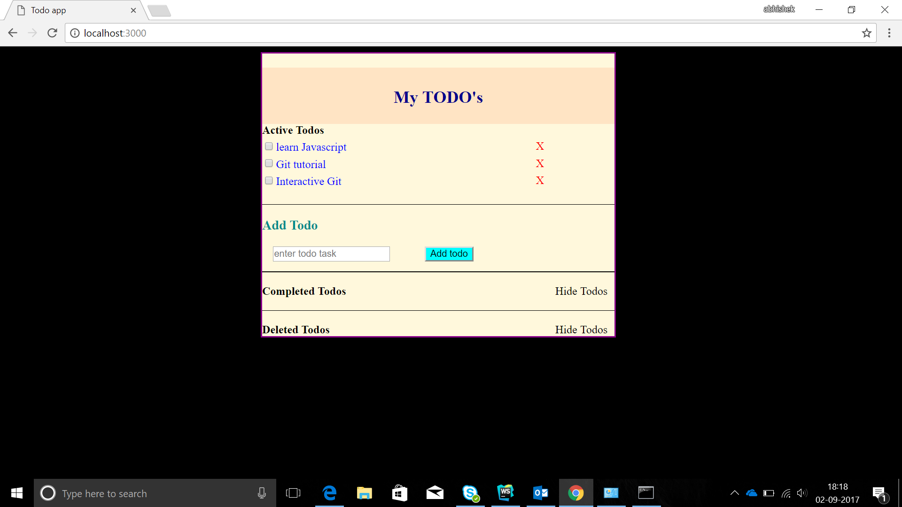

1. Adding a Todo:

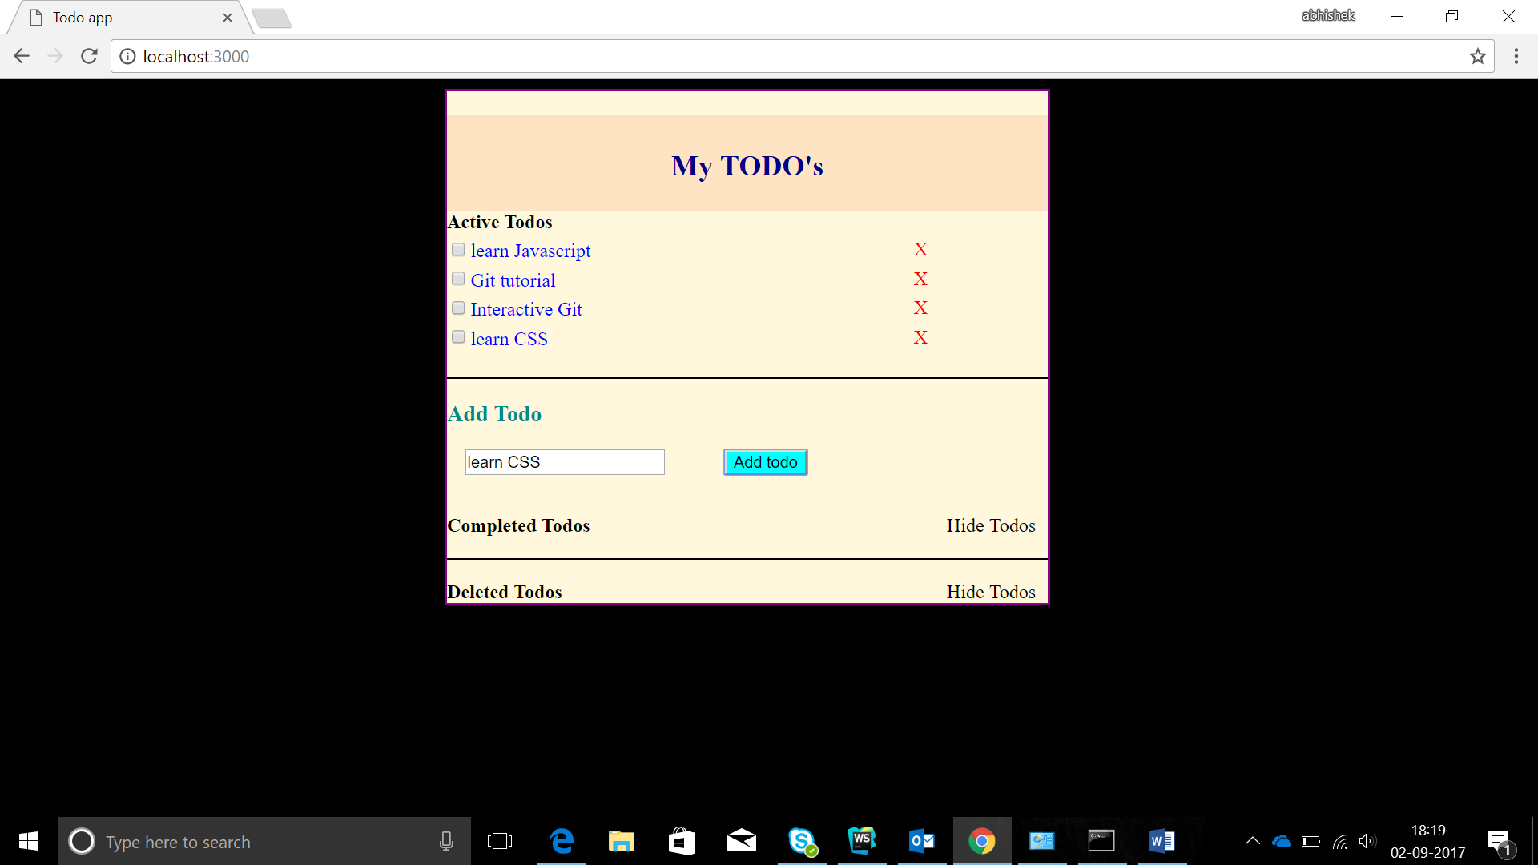

1. Complete a Todo:

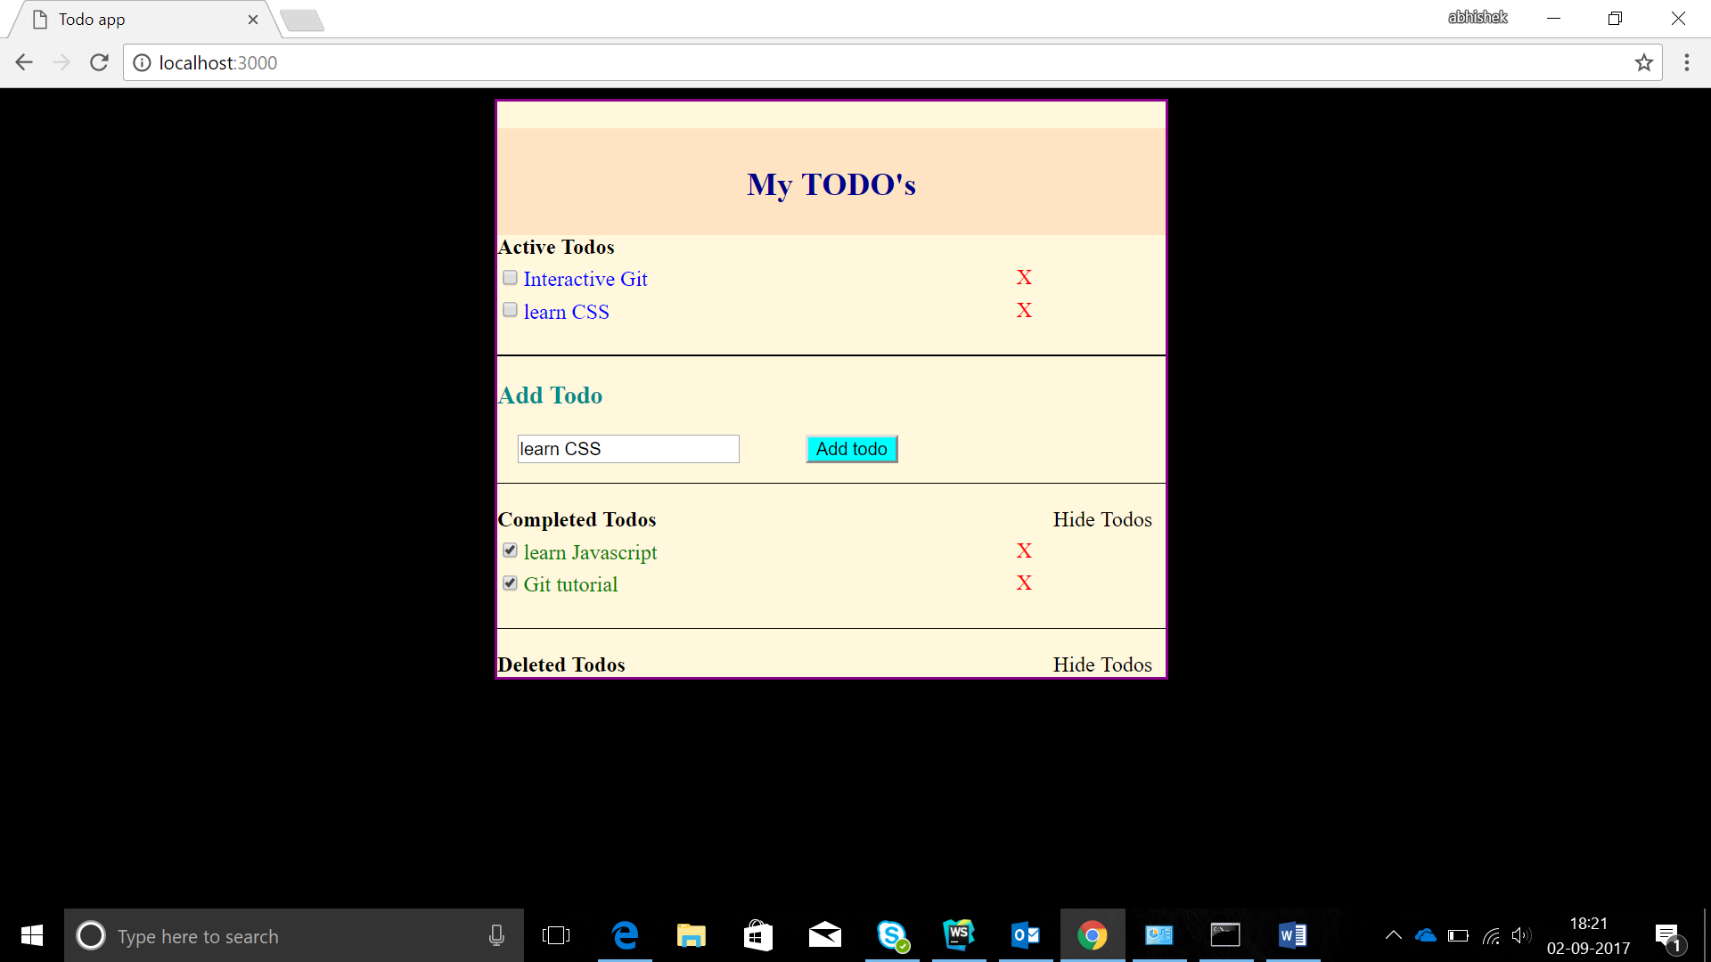

1. Deleting a Todo:

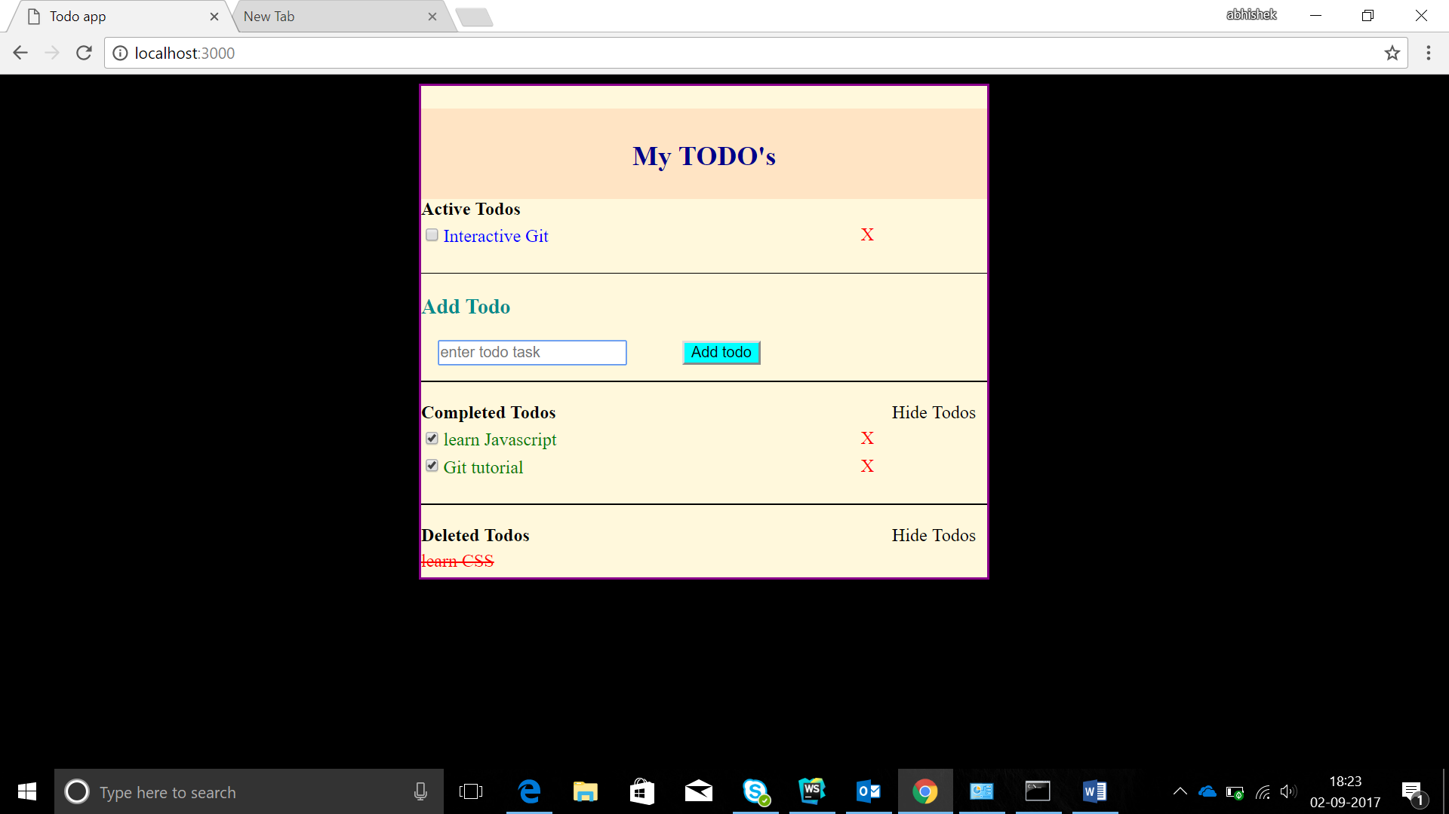

1. Reactivating a Todo:

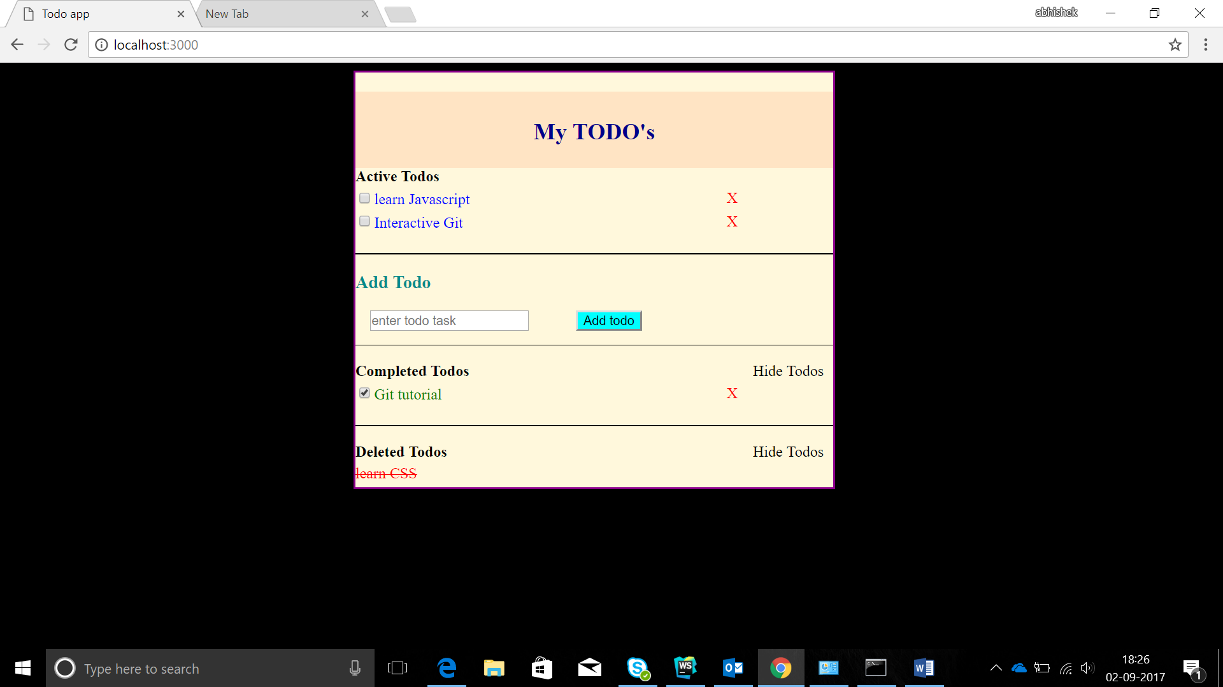

1. Hiding todos:

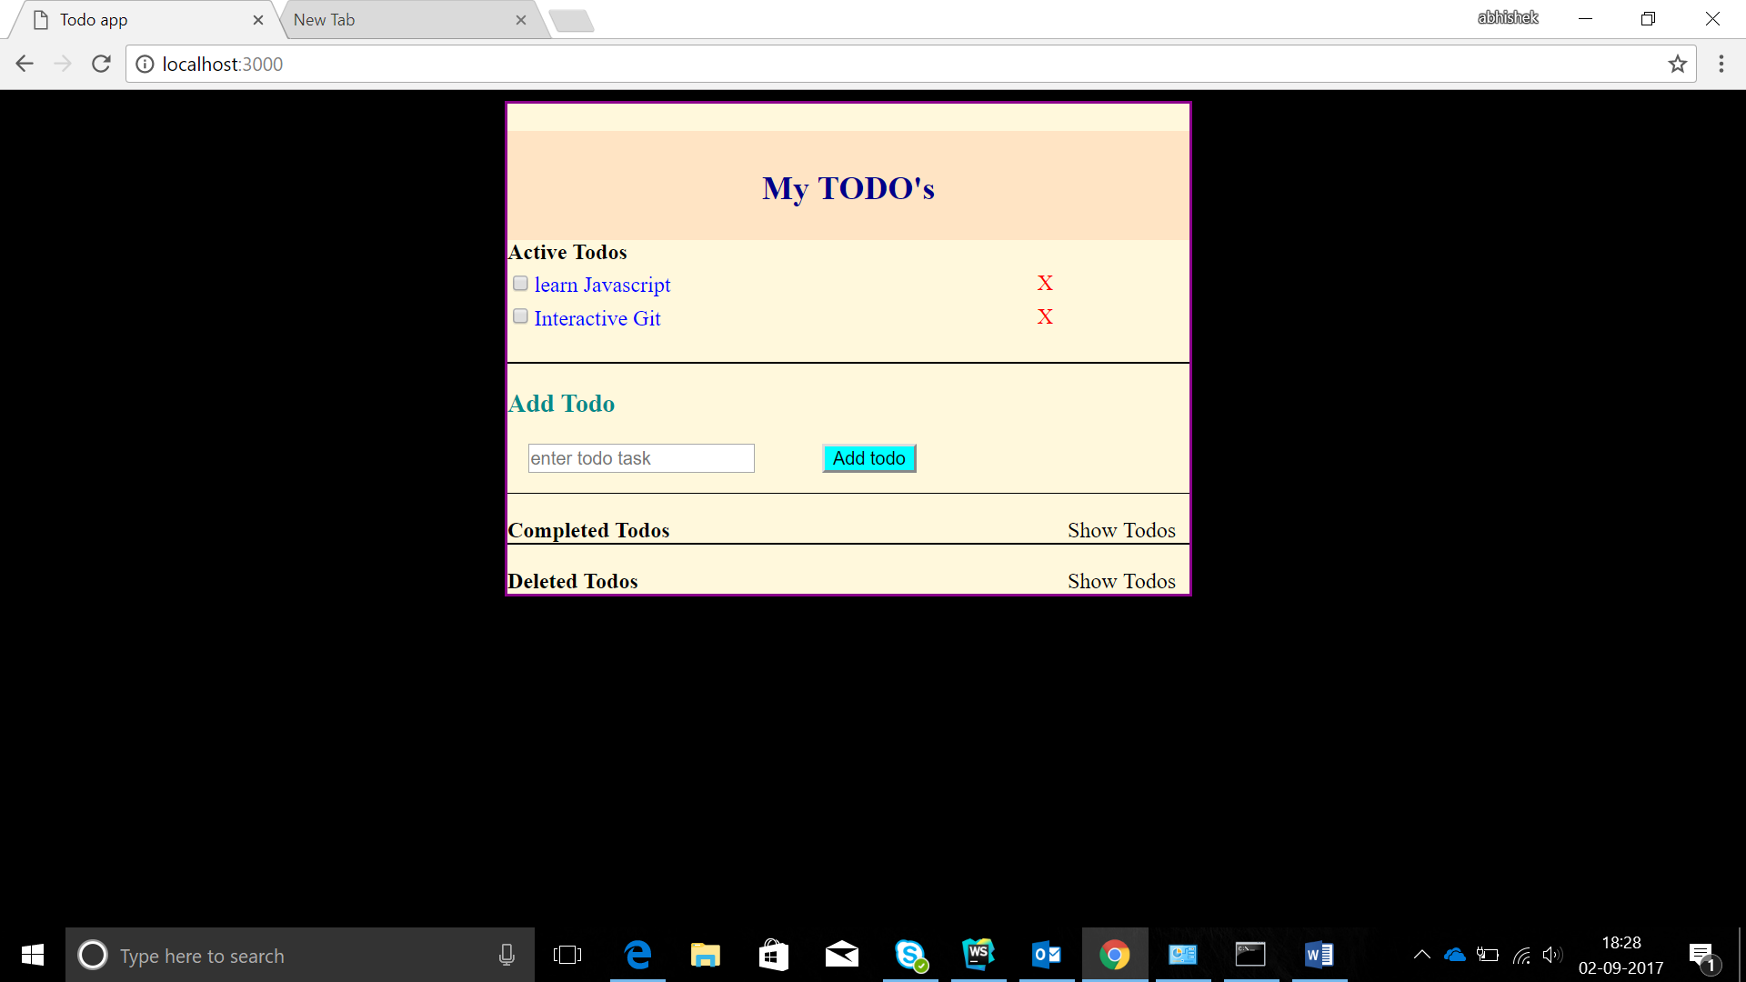

1. Showing Todos again:

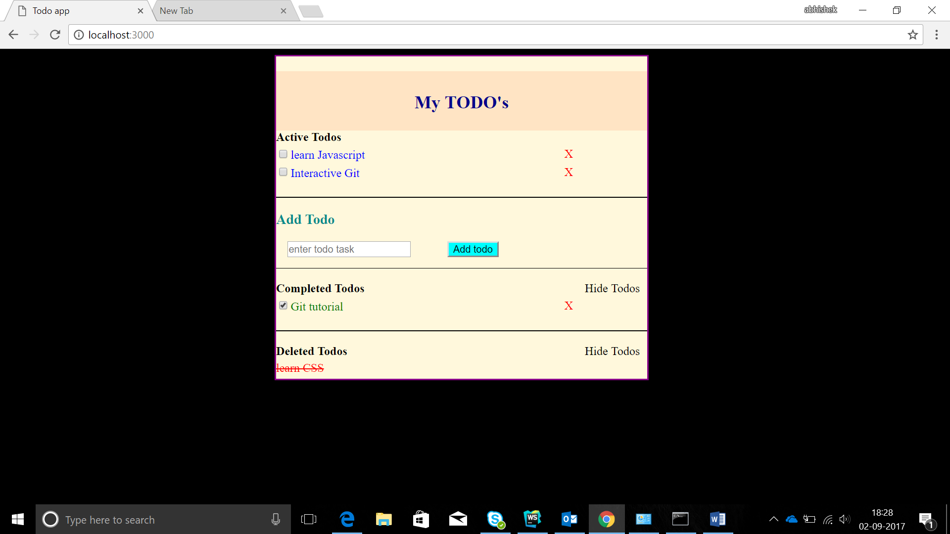

By: Abhishek Aggarwal

Emp code: 3146427